**Week 3: UML Diagrams [Class and UseCase]**

1. Evaluation of uploaded SRS document.
2. Explanation of conceptual model of UML with use case and class diagram taking ATM as example.

**Objective :**

**To understand and apply the concepts of UML by creating a conceptual model, a use case diagram, and a class diagram for their respective project.**

Unified Modeling Language (UML) diagrams are a way to visualize systems and software. It helps the software engineers understand designs and proposed implementation of complex software systems.

UML (Unified Modeling Language) diagrams are categorized into two main types: **Structural diagrams** and **Behavioral diagrams**. These diagrams serve to model different aspects of a system, from its architecture and components to its behavior and interactions.

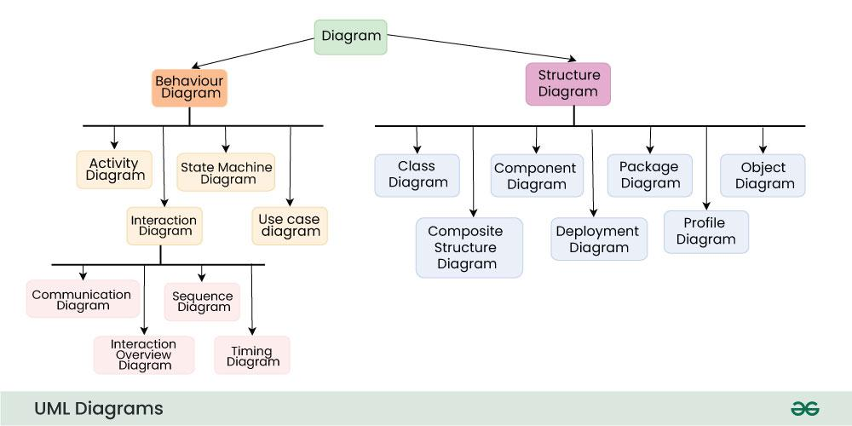

**Use case :**

A **use case diagram** is a visual representation used in software engineering to depict the interactions between a system and its external actors.

**Key Elements of Use Case Diagrams:**

1. **Actors**:
   * Represent external entities that interact with the system. They can be users, other systems, or devices.
   * Depicted as stick figures.
2. **Use Cases**:
   * Represent the functions or actions the system can perform.
   * Depicted as ovals.

**Steps:**

**1. Understand the ATM System:**

*Functionality*: An ATM (Automated Teller Machine) allows users to perform financial transactions like withdrawing cash, checking account balance, transferring money, etc.

Actors: Identify the main actors interacting with the system (e.g., Customer, Bank Server).

**2. Create the Use Case Diagram:**

Identify Use Cases: List out the use cases for the ATM system. Typical use cases might include:

* Withdraw Cash
* Check Balance
* Deposit Cash
* Transfer Funds
* Change PIN

Draw the Use Case Diagram:

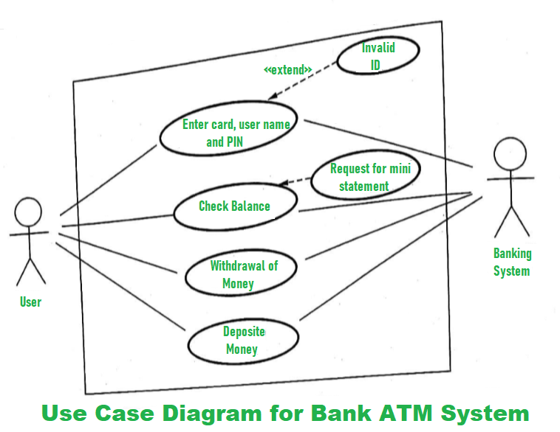

**3. Develop the Class Diagram:**

A **class diagram** is Structural diagrams in UML used to represent the static structure of a system. It shows the system's classes, their attributes, operations (or methods), and the relationships between the classes.

**Key Elements of a Class Diagram:**

Class:A class is represented by a rectangle divided into three sections:

* **Class Name**: The top section contains the name of the class.
* **Attributes**: The middle section lists the class's attributes (properties or fields), which describe the characteristics of the class.
* **Methods/Operations**: The bottom section contains the class's methods or operations, which define what the class can do.

Relationship : Relationships between classes describe how classes are connected or interact with each other within a system.

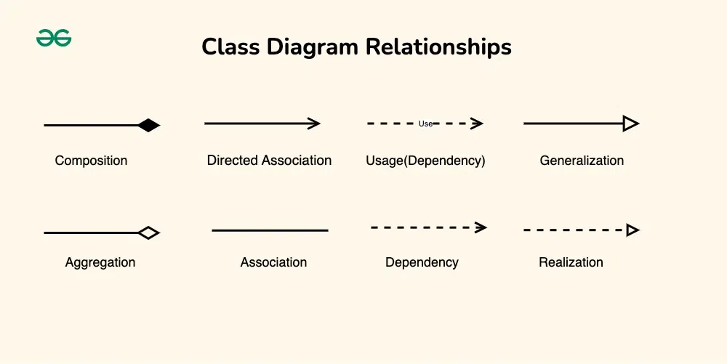

Identify the classes, their attributes and methods. Finally the relationships between classes.

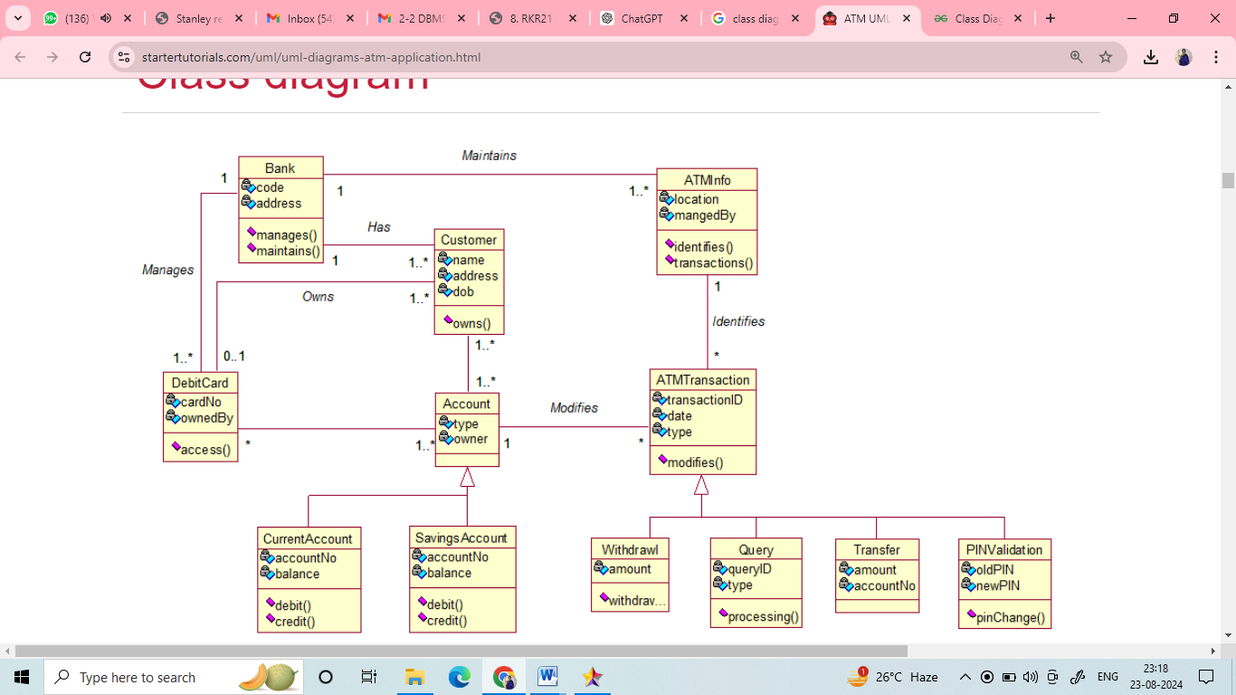

**Conclusion:**

By following these steps, students will create a conceptual model for their respective project using **Star UML** The use case diagram captures the functional requirements, and the class diagram represents the system's structural design.

**Note: Upload your work in the tesselator.**